Github Repository link :-

<https://github.com/kongaresanket27/Formitaoe.ac.in>

Preskilet link :-

<https://preskilet.com/202401040057@mitaoe.ac.in>

Cisco certificate :-

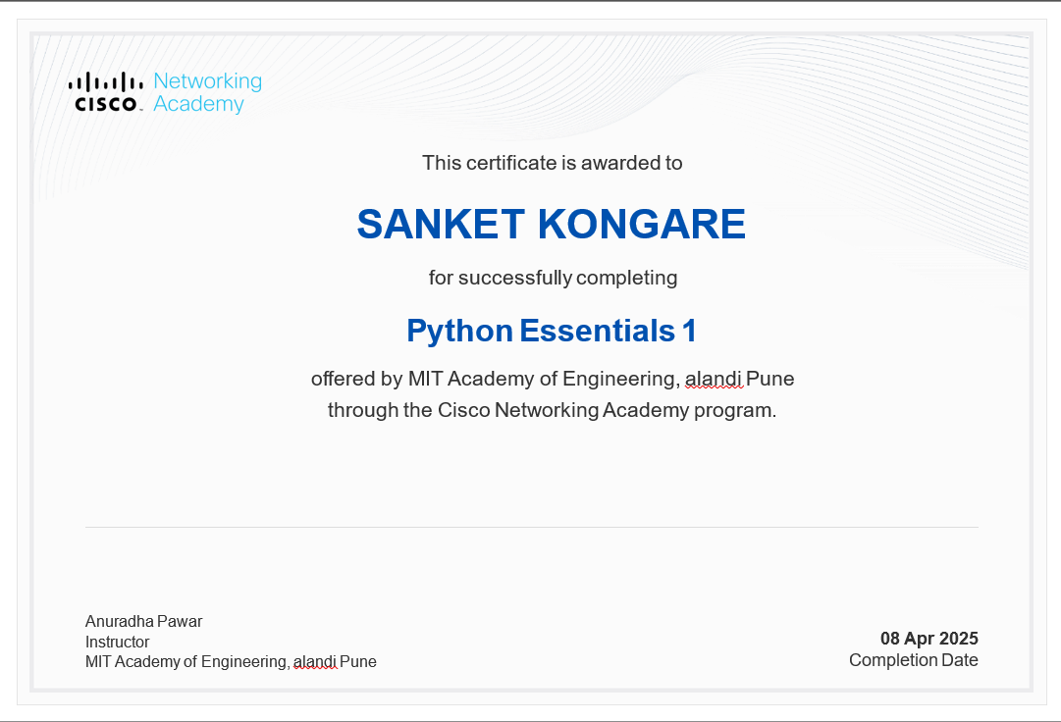

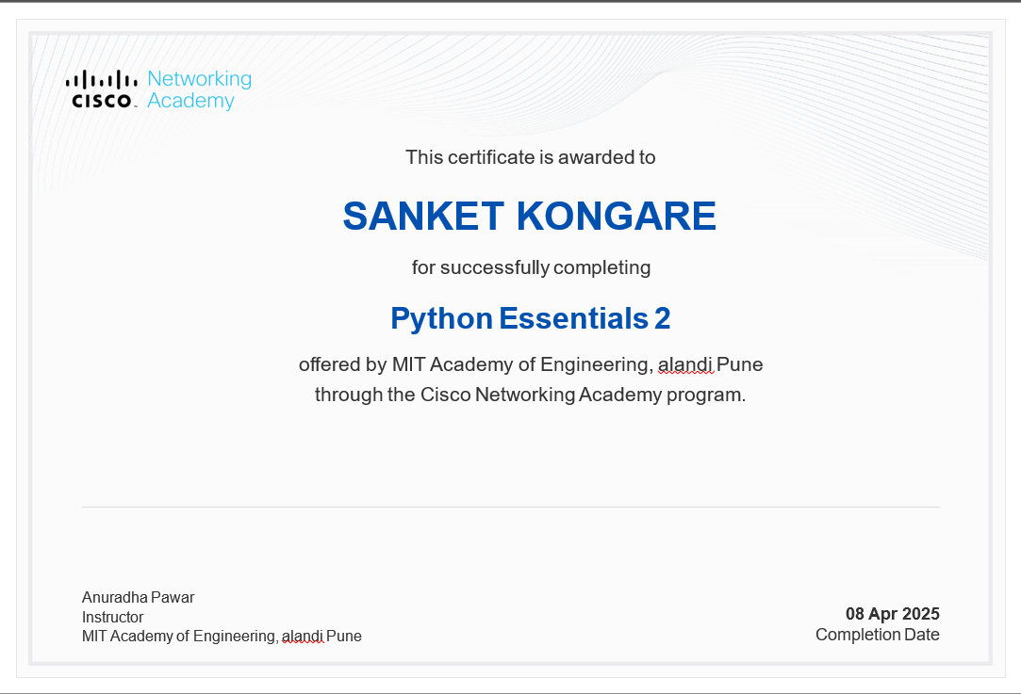

Lab assignment :

